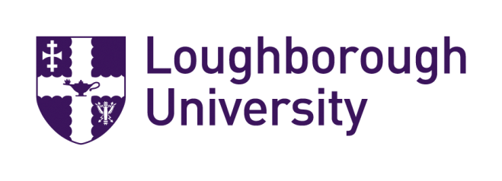
Loughborough University拉夫堡大学
1+1 Partnership Programme
Loughborough University and Nankai University

A Quality Environment
Loughborough is located in the centre of England about 90 minutes by train from London. Our single-site campus is the largest in the UK with attractive gardens, superb sports areas and plentiful accommodation for students.
Loughborough now has 17,000 students of which around 16% are international students.
There are over 2,600 international students studying at Loughborough – roughly 42% at postgraduate taught Masters level, 39% at undergraduate level and 19% at postgraduate research level.

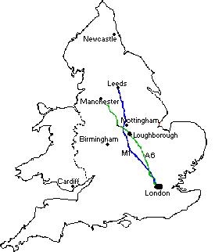
A Quality Reputation
- Awarded Gold in the Teaching Excellence Framework 2017
- Ranked 6thin the UK in the Guardian University Guide 2018 , top ten in the Complete University Guide 2018 and 7thin the UK in The Times Good University Guide 2018
- UK’s Best Student Experience over the last 10 years Times Higher Education 2007 - 2017
- Voted 1st for University Facilities -Whatuni Student Choice Awards 2017
- Also voted Best Student Union and Best Accommodation byWhatuni 2015
- Top 10 in England for research intensity – Research Excellence Framework 2014
- Loughborough has been ranked 6th safest place to live by students
- Ranked in the top 5 in the UK and top 40 in the world for graduate employment by the QS
- Best sporting university in the world - QS World University Rankings 2017
Loughborough - Nankai Partnership
Loughborough University (LU) and Nankai University (NKU) now have a partnership to offer NKU students an exclusive opportunity to earn two master’s degrees within two years! The 1+1 programme structure is:

1 year of postgraduate study at NKU
1 year of postgraduate study at LU (awarded two master’s degrees: one from NKU and one from LU)

The 1+1 programme enables NKU students to gain exposure to world-leading teaching and research in Social Sciences in China and the UK.

All successful NKU applicants will receive a 10% bursary and outstanding NKUstudents will be considered for scholarships.

NKU students will choose from the following postgraduate master’s programmes at LU:
- MA Global Media & Cultural Industries
- MA Media & Cultural Analysis

- MA Digital Media & Society
- MA Global Political Communication
  - MA Media & Creative Industries
  - MA Communication & Cultural Policy
  - MA Global Communication & Development

Entry Requirements
NKU students must achieve the below for entry to LU for the 1+1 programme:
- Minimum 80% in the first master’s year at NKU
- IELTS 6.5 overall (6.0 minimum in each sub test)
Pre-sessional English Language tuition is available for those applicants whose scores in English Language fall slightly below those which are normally expected for entry. The Pre-Sessional courses available are 10 weeks (IELTS 6.0 (6.0 in sub tests) for entry) and 6 weeks (IELTS 6.5 (5.5 in sub tests) for entry).

Further information& Application Support
If you would like more information about this partnership please contact:
Nankai University:  Professor Feng  Dean, School of Literature  dajian@nankai.edu.cn | Application Support:  Ms Sophie Cao, Managing Director  Golden Arrow Agency  T: +86 (0)10 65273032  Email: sophie.cao@ukpass.org | Loughborough University:  Caroline Feeley  International Partnerships Manager  Tel: +44 (0)1509 223 466  Email: c.m.feeley@lboro.ac.uk
Department of Social Sciences (Loughborough)
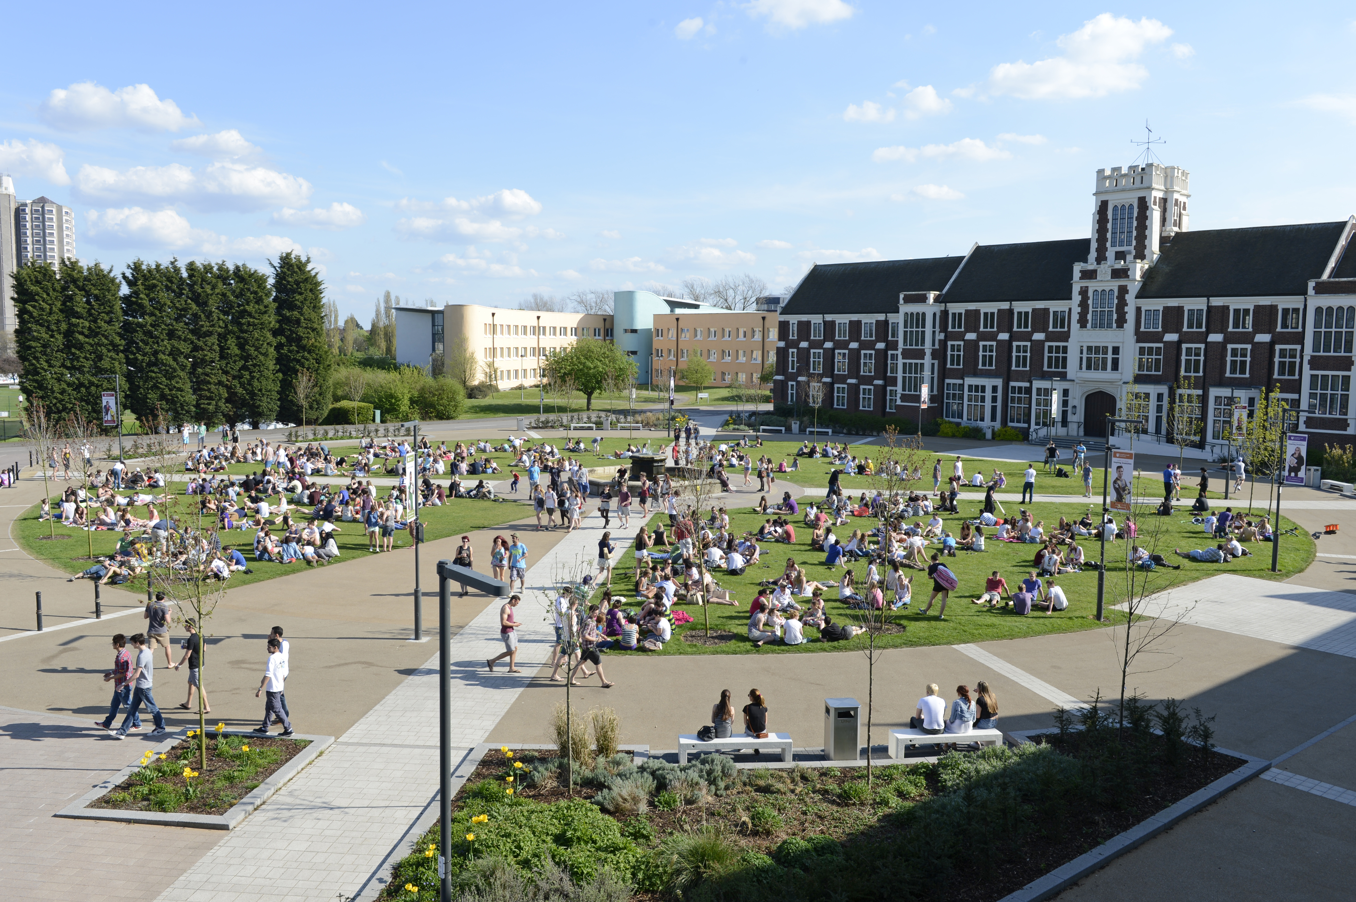 | In the Department of Social Sciences we offer a rich variety of taught postgraduate masters. The courses are delivered by an internationally renowned interdisciplinary team, through the use of contemporary case studies and research-informed applied teaching and learning.  The courses provide training in digital culture, media, communications, sociological, anthropological, theory, as well as quantitative and qualitative methods. They prepare our graduates for the real world of the television industry, marketing, academia, publishing, plus many more industries

Institute for Media & Creative Industries (London)
You will have the opportunity to gain contextual understanding of this highly popular field in a city globally renowned for its Media Creative Industries. In addition, you will have access to wide-ranging industry networks and events gaining first-hand knowledge and exposure to potential employment sectors.  Based in the former Olympic International Broadcast Centre, our neighbours include BT Sport broadcasting company, owners of Europe's largest Sport TV studios. Along with providing a strong theoretical foundation, these connections mean that the programme can also offer unique opportunities for students to gain industry exposure and insights into the practical aspects of the media industry.  http://www.lborolondon.ac.uk/ | 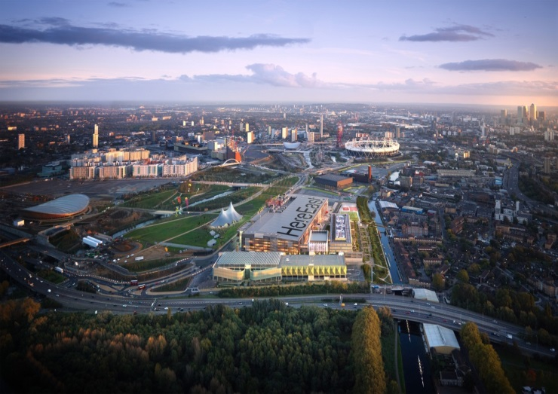

Fees & Finances
Tuition fees 2018/19
 | Standard Fee |  | Fee with 10% bursary
LU Year (Loughborough) | £17,100 | RMB 150,420 | £15,390 | RMB 135,354
LU Year (London) | £17,500 | RMB 153,961 | £15,750 | RMB 138,573
Exchange rate based on £1 = 8.Chinese Yuan RMB, November 2017. These fees are intended as a guideline only. Applicants are advised to check the fees on the web:http://www.lborolondon.ac.uk/study/fees-finance/
Living costs (estimated):
- Loughborough: £11,600 should cover a postgraduate living in self-catered halls for 50 weeks
- London: £15,000 should cover a postgraduate living in London for 50 weeks
Living costs include accommodation, food, travel, leisure and personal expenditure.

 | Fees |  | Living expenses |  | Total
(10% bursary) | £ | RMB | £ | RMB | £ | RMB
LU Year (Loughborough) | £15,390 | 135,354 | £11,600 | 102,023 | £26,990 | 237,379
LU Year (London) | £15,750 | 138,573 | £16,000 | 140,724 | £31,750 | 279,249

Accommodation (Loughborough)
We offer four postgraduate halls of residence on, or close to, campus. All of these are self-catered halls, with 24-hour security. Our Student Accommodation Centre also provides support to students searching for private accommodation.

Accommodation (London)
We have approved a number of secure and friendly accommodation options to suit you and your budget. These include:
- Unite Stratford One – opposite the campus, single en-suite rooms or studio apartments
- Claredale House – located in Bethnal Green, 2.5 miles from campus, single rooms in shared apartments
- East Village – former Athletes’ Village, 5-minute walk from campus, apartments with 1, 2 or 3 bedrooms
For more information please visit: http://www.lborolondon.ac.uk/about/location/accommodation/

How to apply
Please request an application form for the LU-NKU China Partnership from Ms Sophie Cao, Managing Director of Global Arrow Agency in Beijing. Contact details are listed over the page.

